EXERCISE 8.2

Question 1:

Evaluate the following:

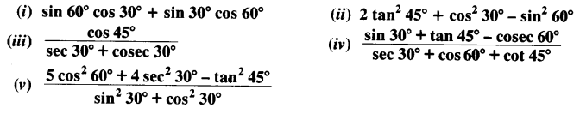Solution:

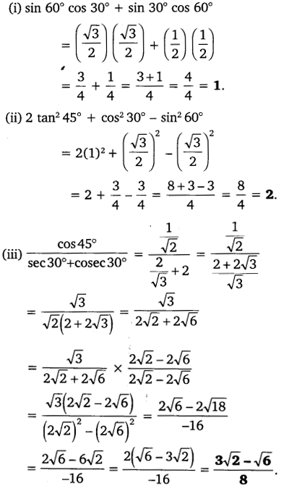

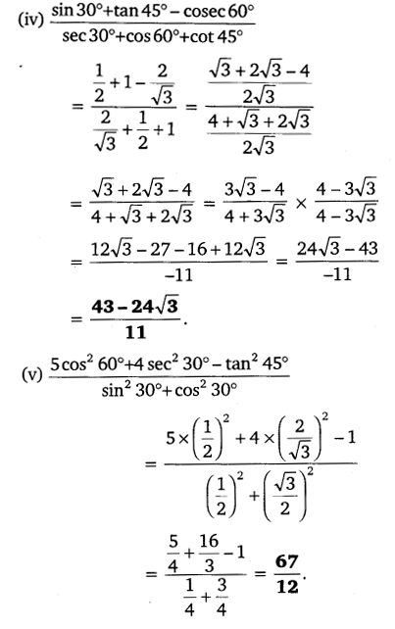

Question 2:

Choose the correct option and justify your choice:

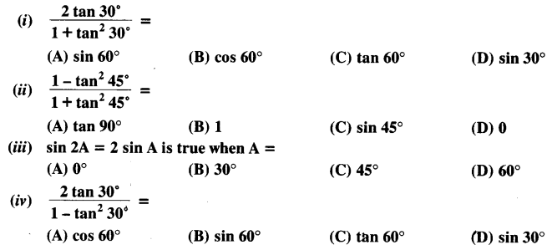Solution:

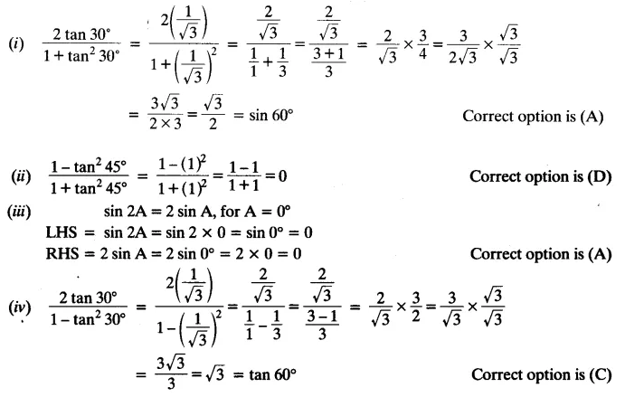

Question 3:

If tan (A + B) = √3 and tan (A – B) = 1/√3; 0° < A + B ≤ 90°; A > B, find A and B.

Solution:

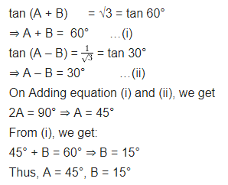

Question 4:

State whether the following statements are true or false. Justify your answer.  
(i) sin (A + B) = sin A + sin B.  
(ii) The value of sin θ increases as θ increases.  
(iii) The value of cos θ increases as θ increases.  
(iv) sin θ = cos θ for all values of θ.  
(v) cot A is not defined for A = 0°.

Solution:

